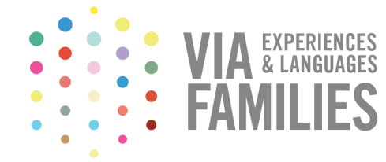

Partnership agreement

between Family community and

the organization XXXXXX

GATHERED
On the one hand, Mrs. Ana Trinxet, representing the company Family Community S.L with registered offices in Avda. Pau Casals 4, 08021 Barcelona with tax indication number B66463332 (hereinafter called Via Families)
On the other hand, Mr/Mrs XXXXXX, in the name of and representing XXXXX with registered offices in XXXXXX, (Postcode), (City) with the tax indication number XXXXX (hereinafter called XXXXX)

ACTING
- That Via Families is a website for languages and cultural exchange of students between families with common needs and interests which objective is:
- To defend the rights of every student, to have the same opportunities without any economic, social or physical discrimination.
- To contribute to the education of your children
- To encourage student mobility to make culturally open-minded citizens
- To promote the involvement of educational entities for the children in your families, helping them to prove their identities.
- To push the education at the international level
- As a S.L company, it obeys to all of the current legal framework and to the Spanish law of the protection of personal data.
- As a legal representative of Via Families, Family Community S.L is not responsible of any agreement of final exchange that the family reach through the website.
- That XXXXXX is XXXXXX and its objectives are XXXXXX.
- And that Via Families and XXXXX are both interested to collaborate for the improvement and to preserve education. It offers a platform for each family of the organization to improve the education of their children by doing cultural, linguistic or another type of educational exchanges by contacting directly other families to do these exchanges in benefit of the community of Via Families.
In that way, and on the basis above mentioned, both parties

AGREED ON
FIRST
Compensation
From this present contract, Via Families will do a contribution agreed between the parties from the account of XXXXX 0000 0000 00 000000000 from XXXXXX bank by bank transfer in the following terms:
- When a family from the organization contact another family through the platform of Via Families from the date of the signature and until the 1st of February 2018
- When a family from the organization pay the annual Premium fee to be part of Via Families and that contact through the platform other families.

SECOND
Compensation of XXXXXX
XXXXX engage itself to allocate this economic contribution to actions that benefits directly or indirectly students and their families by realising these kind of actions:
Examples:
- Student grants
- Medical investigation
- Helps in studies
- Financial support to families

THIRD
Duration of the agreement
The contract will be in force for one year, from the signature, that can be yearly extended from a mutual agreement and in writing.
And in witness whereof, the appearing parties sign in duplicate and to one sole effect, in
Barcelona the ________ ___________, of 201_

____________________________ ____________________________
XXXXXXXX VIAFAMILIES.COM
Signature of the legal representative Ana Trinxet Rosselló

